**User Guide**

**Single Sign On**

**Version 1.0**

|  |  |  |
| --- | --- | --- |
| Project | : | [Sitecore](https://eportal.exact.nl/docs/PRProjectDossier.asp?FromView=1&ProjectNr=MTPRODMAN.009.006) test |
| Author | : | [Stephen Chong](https://eportal.exact.nl/docs/EPEmployeeDossier.asp?ID=28591) |
|  | : |  |
| Date last modified | : | Wednesday, 01 May, 2018 |

# Application

1. SSO BackOffice

<http://localhost/WebServices>

|  |
| --- |
|  |

1. Site client

<http://localhost/SiteClient>

|  |
| --- |
|  |

### Register new user

1. Go to site client and click on New user button

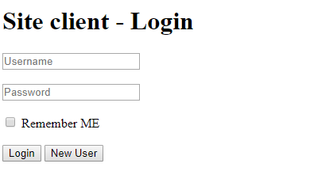

1. Registration page show

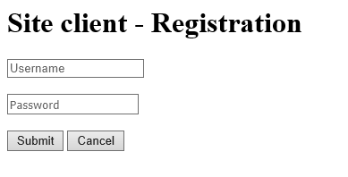

1. Enter preferred username and password. Then click submit button.

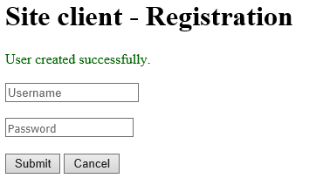

### Single Sign on

1. Go to SSO BackOffice. Enter your username and password. Check remember me and click login button

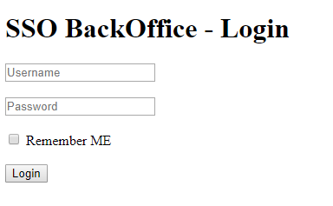

1. Login successfully.

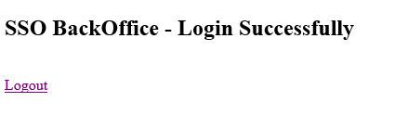

1. Now, go to <http://localhost/SiteClient> . Notice you already login into client site.

